

International Journal of ChemTech Research
CODEN( USA): IJCRGG ISSN : 0974-4290
Vol.5, No.6, pp 2769-2781, Oct-Dec 2013

Chemical Changes and Antioxidant Activity in Arils Juice of two Syrian Pomegranate Accessions during Fruit Maturation

Rahaf Al-Halabi*, Iman Al-Bakri, Malak Al-Joubbeh.

Chemistry department, Faculty of Science, Damascus University, Damascus, Syria.

*Corres. Author: alhalabi.Rahaf@gmail.com
Mobile: +963 944405501

Abstract: Polyphenolic compounds concentration of pomegranate fruit is affected by cultivar, environment, and development stage of fruits.
In this study, some chemical characteristics were determined in fruit during maturation stages every 20 day from the 30 to the 150 day-old fruit of two pomegranate accessions locally called ‘HeloErbin’(AE) and ‘Lafan Al-Hesn’ (AH) grown in Syria.
The highest concentration of Anthocyanins (281mg cy-3-glu/L) was recorded in the 150 day-old fruit in AE accession which has a sweet taste and strong red aril colour. While the highest concentration of total phenolics(2457mg GE/L), flavonoids (570 mg QE/L), ellagitannins(572 mg EA E/L ), condensed tannins(511 mg cy E/L), and punicalagin, the most important bio-active compound in pomegranate juice, (319 mg/L), antioxidant activity (22 mM AE/L) ,as well as, the highest inhibition of LDL oxidation were recorded in the 30 day-old fruit in AH accession which have an astringe taste. The results provide important information on the changes in chemical properties of pomegranate fruit during ripening, which is very useful for determination of the fruit quality.
Key words: pomegranate arils juice, maturation, polyphenols, punicalagin, antioxidant activity, LDL oxidation, Syria.

- Introduction
Red fruits are rich dietary sources of antioxidant phenolics and anthocyanins. ¹It has been reported that pomegranate juice is one of the important sources of anthocyanins, which give the fruit and aril its red colour, and some of the phenolics and tannins.²The consumption of pomegranate juice has been reported to have many positive health benefits because of the high level of antioxidant capacity of the juice.³Pomegranate fruit contains anti-carcinogenic, antimicrobial, and anti-viral compounds.⁴ Recent biological studies have proven that certain compounds contained in pomegranate juice, which are anti-atherogenic and signiﬁcantly reduce LDL oxidation.⁵The antioxidant capacity of commercial pomegranate juice is three times higher than those of red wine and green tea.⁶ The principle antioxidant polyphenols in pomegranate juice include the ellagitannins, proanthocyanidins, andanthocyanins. ^{7,8}Significant differences have been reported in the concentration of some individual phenolic compounds of different pomegranate cultivars affecting the antioxidant capacity of Pomegranate Juice.⁹ Antioxidant capacity of Pomegranate juice, like of other fruits, depends on cultivar, growing region, climate, maturity and cultural practice. Also technology used to obtain Pomegranate juice may affect the antioxidant capacity.¹⁰Due to the extensive knowledge about the pomegranate’s health attributes and increasing public awareness about nutritional food, pharmaceutical companies, which extracted health beneﬁcial
Rahaf Al-Halabi et al /Int.J.ChemTech Res.2013,5(6) 2670

compounds from the fruit,haveincreased signiﬁcantly in many regions .¹¹Although, knowledge of the importance of pomegranates inhuman nutrition has increased tremendously in recent years, the chemical composition of the pomegranate fruit during fruit maturation has not yet been studied in Syrian pomegranate. Chemical changes occurring during the fruit maturation stages can affect the nutritional value and health properties of the pomegranate fruit.The objective of our study was toinvestigatechanges in the major chemical composition, Punicalagin(which is the major bio-active compound responsible for pomegranate juice's antioxidant and health benefits)¹² (Fig.1) ,along with antioxidant activity in pomegranate arils juice during different stages fruit development and maturation in two Pomegranate accessions grown in Syria.

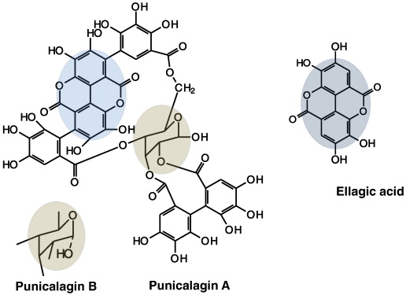
Fig. 1. Structures of punicalagins A and B, and ellagic acid

2. Materials and methods
2.1. Chemicals
Quercetin, DPPH, gallic acid, Folin–Ciocalteu reagent, ellagic acid, and punicalagin (HPLC grade)were purchased from Sigma-AldrichCo.Ascorbic acid was obtainedfrom Riedel-de Haën. Acetonitrile and orthophosphoric acid were of HPLC grade, All other chemicals used were of analytical grade.
2.2. Plant materials and fruit processing
Two different pomegranate accessions were chosenfor this study (astringe accession "lafan Al-Hesenreffered as AH and sweet one"HeloErbin" reffered as AE).Young fruits of each accession were marked when fruit set, three fruitsfrom each accession were harvested every 20 days during fruit maturation. The peels and arils were separated from every fruit obtained foreach pomegranate accession during every harvested time and juice was prepared bysqueezing the arils by manual machine depending on triturate the arils and ﬁltered through ﬁlter paper (Whatman no.40). The fresh juices were analyzed for major chemical composition and antioxidantactivity, except HPLC analysis which made on frozen juices at -20 ⁰C.
2.3. Determination of total phenolic content
For total phenol compounds determination, (1:10 in methanol 80%) dilutions of the juices were used. Total phenolic were determined using the colorimetric method.⁴200 μl of the juice samples/standard wasmixed with 400μlof Folin–Ciocalteureagent and 4ml of distilled water. After ten minutes, 2ml of7% Na₂CO₃ were added, thesampleswere stored for 2 hours at thedark. The absorbance of the samples was measured at 760 nm by a UV–Visible spectrophotometer (Optizen 3320UV). Final results were expressed as mg gallic acid equivalent per L of Pomegranate Arilsjuice (mg GE/L).

Rahaf Al-Halabi et al /Int.J.ChemTech Res.2013,5(6) 2671

2.4. Determination of total anthocyanin content

Total anthocyanin was determined by pH differential method ⁹ using two buffer systems: potassium chloride buffer, pH 1.0 (0.025 M) and sodium acetate buffer, pH 4.5 (0.4 M). Brieﬂy 0.4 ml of PJ sample was mixed with 3.6 ml of corresponding buffers and read against water as a blank at 510 and 700 nm. Absorbance was calculated as:
A=(A₅₁₀-A₇₀₀)pH_{1.0} –(A₅₁₀-A₇₀₀)pH_{4.5}
Total anthocyanin content (TAC) of samples (mg cyanidin-3-glucoside/1L of PJ) was calculated bythe following equation:
TAC=(AxM_{W}xDFx1000)/M_{A}
Where A: absorbance; M_{W}: molecular weight (449.2); DF: dilutionfactor (10); M_{A}: molar absorptivity of cyanidin-3-glucoside (26900).

2.5. Determination of total ﬂavonoid content
For the total ﬂavonoid content, the method described in ¹³ was used. One milliliter of (1:5 in methanol 80%) dilutions of pomegranate juice were mixed with 0.3 ml NaNO₂ (5%). 0.3 ml of AlCl₃ (10%) were added after 5 min , and after 6 min were neutralized with 2 ml NaOH solution (1M). For all the samples the absorbance was read at 510 nm and the quantiﬁcation was carried out using a calibration curve of quercetin. The results were expressed in mg quercetin equivalents per L (mg QE/L).
2.6. Determining of condensed tannins (proanthocyanidins) content
A colorimetric assay (butanol-HCl assay)¹⁴ involves the oxidative cleavage of proanthocyanidins with ferrous sulfate. 0.5 mL of (1:100 in distilled water) dilutions of juice is added to a 5mL portion of an acidic solution of ferrous sulfate (77 mg of FeSO4.7H2O dissolved in 500 mL of 2:3 HCl/n-butanol). The tubes are loosely covered and placed in a water bath at 95°C for 15 min. The absorbance is read at 530 nm. The concentration of proanthocyanidins is expressed as cyanidin equivalents (mg cy E/L) .The molecular extinction coefficient ε_{mol} that can be used to convert the absorbance values to a concentration is equal to 34700 Lmol⁻¹cm⁻¹.
2.7. Determination of ellagitannins content
Ellagitannins determined as described in¹⁴. After hydrolysis of ellagitannins, ellagic acid concentration can be determined through an oxidation reaction with nitrous acid. To maximize the formation of a red-colored product in the assay the sample containing ellagic acid is dissolved in pyridine to a volume of 2.1 mL. A volume of 0.1 mL concentrated HCl is added, and the mixture is brought to 30°C. After a volume of 0.1 mL 1% (w/v) NaNO₂ is added, the mixture is quickly mixed and the absorbance at 538 nm is read immediately afterwards (A₅₃₈, t₀). After 36 min at 30°C the red product reaches its maximum concentration, and the absorbance (A₅₃₈,t₃₆) is recorded again. The ellagic acid concentration in the sample is a function of the difference between (A₅₃₈,t₀) and (A₅₃₈,t₃₆).A stander curve of ellagic acid was used. The ellagitannins was expressed as mg ellagic acid per L.(mg EA E/L)This procedure is based on the formation of the electophile NO⁺ which can react with an ellagic acid residue .
2.8. Evaluation of total antioxidant activity
Total antioxidant activity was estimated by two methods DPPH and FRAP.
2.8.1. Ferric reducing antioxidant power (FRAP)
The ferric reducing power (FRAP) of pomegranate juice arils was determined by using thepotassium ferricyanide-ferric chloride method as described in ¹³. One mL of juice was added to 2.5 mL phosphate buffer (0.2 M, pH 6.6) and 2.5 mL potassium ferricyanide (1%). The mixtures were incubated at 50 °C for 20 min, after which 2.5 mL trichloroacetic acid (10%) was added .An aliquot of themixture (2.5mL) was taken
Rahaf Al-Halabi et al /Int.J.ChemTech Res.2013,5(6) 2672

and mixed with 2.5 mL water and 0.5 mL 0.1% FeCl3. The absorbance at 700 nm was measured afterallowing estimated in terms of Ascorbic acid equivalent antioxidant capacity inmmol/L (mMAE/L).
2.8.2. DPPHradical scavenging activity
Radical scavenging potential Antioxidants react with DPPH, which is astable free radical, and convert it into α, αdiphenyl-β-picryl hydrazine. The degree ofdiscoloration indicates the scavenging potential of the antioxidant.
Antioxidant activity was determined by the DPPH method described by ¹⁵with some modifications.(1:10 in methanol 80%) dilutions of the juices were used. (200μl) of diluted juicewas mixed with 3 ml of DPPH (45μg/ml in methanol 80%).The mixture was shaken vigorously and left to stand for 30 min. Absorbance of the resulting solution was measured at 517 nm.The antioxidant activity was calculated using the following equation:
Antioxidant activity (%) = (1-[A _{of sample}/A _{of control}]) x 100
2.9. Inhibition of low density lipoprotein (LDL) oxidation
Inhibition of LDL oxidation was determined according to previous method ¹⁶ with some modification, human serum was collected and diluted by phosphate buffer (50 Mm,Ph 704) to the concentration of 0.3%. Aliquots of 10 ml diluted serum were mixed with 20 μl DMSO or 10 μl DMSO added to 10 μl of pomegranate arils juice from the different ages of pomegranate. TheCuSO4 solution (40 μl of 2.5 mM) was added to initiatethe reaction. The absorbance at 234 nm was recordedimmediately and was taken every 20 min thereafter for 120 min at room temperature.
2.10. HPLC condition for punicalagin and ellagic acid determination
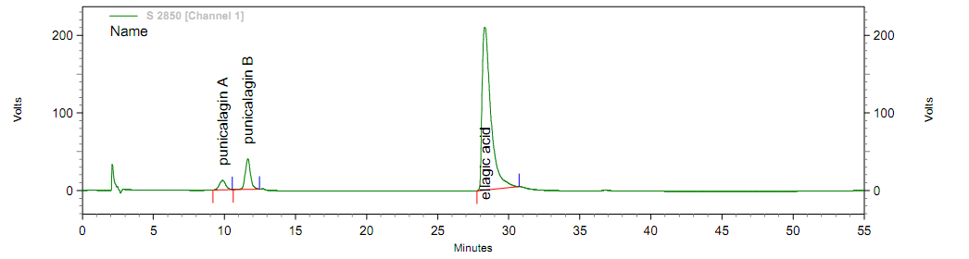
HPLC conditions of ¹⁷ was used with some modifications, the mobile phase solvent A (acetonitrile) and solvent B (0.4% aqueous phosphoric acid), was used under binary linear gradient conditions as follows: 0-10 min, 5-15%solvent A in solvent B; 10-30min, 15-25%solventAin solvent B; with a flow rate of 1.5 mL/min. All samples were filtered (0.45 μm), loaded (25) μL injection volume, and analyzed on KNAUER Vertex plus column 250 X 4.6 Eurospher 100-5 C18. The monitored wavelength was 360 nm for the detection and quantification ofpunicalagins A and B, and ellagic acid. The retention times for punicalagins A and B, and ellagic acid at the above HPLC condition were 9.867, 11.650, and 28.317 min, respectively (Fig.2).

Fig. 2.Punicalagin A and B, and Ellagic acid HPLC chromatogram.

Rahaf Al-Halabi et al /Int.J.ChemTech Res.2013,5(6) 2673

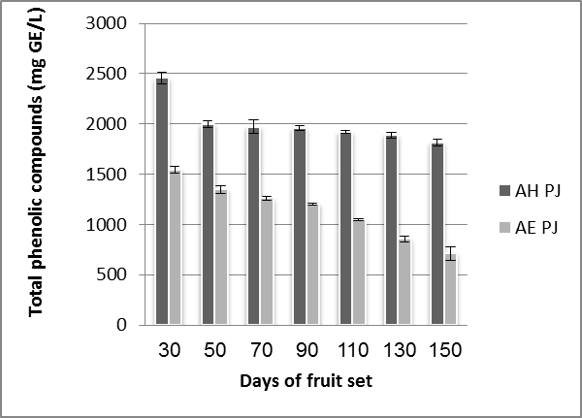
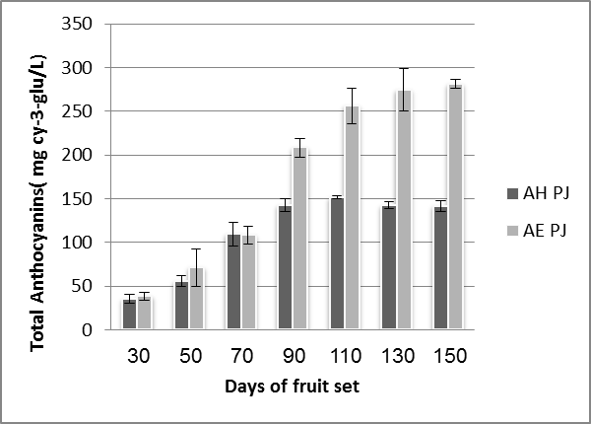

Fig. 3. Total phenolic compounds content represented as mg Gallic acid equivalents (GE) ,and Total Anthocyanins content represented as (mg cyanidin 3-glucoside (cy-3-glu) equivalents per Liter of pomegranate arils juice, during fruit development and maturation in two accession (AH, AE). Data shown are the means of three replicates vertical bar represents ± standard error

3. Results and Discussion
3.1. Compositionalchanges
3.1.1. Total phenolic content and Anthocyanin pigments content
The level of total phenolics was higher in the arils juice of AH accession (AH_{PJ)} than in the arils juice of AE accession( AE_{PJ}) for all fruit development stages. The highest phenolic content (2458 mg GE/L AH_{PJ}, 1545 mg GE/L AE_{PJ}) was recorded in the 30 day-old fruit. There was a nearly 26% AH_{PJ}, 54% AE_{PJ} reduction in total phenolicsfrom 30 to 150 days of fruit development (Fig. 3). Our results agree with other research¹⁸which showed that the total phenolic contents of pomegranate vary considerably from one cultivar to another. The decline in total phenolic may be due to oxidation of phenolic content by polyphenol oxidase that characterizes these stages of maturity, Since total phenolic, especially the hydrolysable tannins, are major contributors to the astringent taste of fruit, their reductions are important in adjusting the fruit taste.⁴ A decrease in phenolic compounds with maturation and ripening has also been reported in banana¹⁹, pear²⁰, guava²¹, andother pomegranate accessions^{2,4,22,23}. Some phenolics are substrates for enzymatic browning. A reduction in the phenolic content with development may reduce the incidence of enzymaticbrowning².
Rahaf Al-Halabi et al /Int.J.ChemTech Res.2013,5(6) 2674

A decrease in phenolics also coincided with an increase in anthocyanin pigment content (Fig. 3). The negative correlations between these two parameters can be explained, as previously suggested, since the ﬂavylium ring required for anthocyanins formation is made from phenolics compounds and this may lead to a reduction in their content and an elevation in anthocyanins levels^{.2,4}The anthocyanins levels in the aril juice were signiﬁcantly increased during maturationin AE accession, which has a strong red aril colour, (from38_{(30 day-old fruit)}to281_{(150 day-old fruit)}mg/L).Anthocyanins levels increasing in AH accession was less (from35_{(30 day-old fruit)}to142_{(150 day-old fruit)}mg/L) (Fig.3)
The highest concentration of anthocyanins was recorded in the 150, day-old fruit in AE accession, and in the 110 day-old fruit in AH accession which was followed by a slight decrease of up to the 150days of fruit development .such decrease in the last stages of maturation was observed in other pomegranate accession and was attributed to a decrease in acidity since the anthocyanin pigments undergo reversible structural transformation with a change in the acidity.²
3.1.2. Total flavonoids content
The total flavonoids levels were reduced by 36% in AH_{PJ} and 34% in AE_{PJ}. The highest Flavonoids content (570 AH_{PJ}, 514AE_{PJ}mg QE/L) was recorded in 30 day-old fruit. (Fig .4)
Areduction in major flavonoids during repining such as (Quercetin 3-glucuronide, Quercetin derivatives, and Kaempferol 3-glucuronide) was found in red raspberries²⁴. The reduction in such flavonoids compounds is the key .Since they used in Biosynthesis of anthocyanins and condensed tannins proanthocyanidins²⁵.

Fig .4. Total Flavonoids content of pomegranate arils juice represented as as mg Quercetin equivalents (QE) per L, during fruit development and maturation in two accession (AH, AE). Data shown are the means of three replicates vertical bar represents ± standard error.

3.1.3. Total proanthocyanidine and ellagitannins content
The proanthocyanidinscontect decreased significantly during fruit ripening in both accessions. The higher concentration of proanthocyanidins (511 mg/L) was observed 30 day-old fruits in AH accession (Fig. 5). The decline in Proanthocyanidins content may be attributed to enzymatic activities such as anthocyanin synthase (ANS) and (LAR) leucoanthocyanidin reductase²⁵. The reduction on proanthocyanidins during ripening was reported in other pomegranate accessions [23], and bilberries⁶. The level of total ellagitannins which belong to the total phenolic compounds such as punicalging, and punicalin, which characterise the pomegranate, were determined during pomegranate maturation for the first time in the current study.
Rahaf Al-Halabi et al /Int.J.ChemTech Res.2013,5(6) 2675

A reduction in total ellagitannins was noticed in both accessions. The intensity of reduction was higher in AE accession (depletion by 54% from 429 _{(30 day-old fruit)} to 197 _{(150 day-old fruit)}) EA E mg/L) than AH accession (depletion by 29% from 572_{(30 day-old fruit)} to 406_{(150 day-old fruit)} EA E mg/L).The higher concentration of ellagitannins was observed in AH accession (Fig. 5). The reduction in ellagitannins content may be attributed to many reasons such as oxidation by PPO ⁴, condensation between ellagitannins and proanthocyanidins may occur depending on enzymes activity and acidity²⁷. It is concluded that loss of astringency, which occurs on ripening, is most probably connected with increased polymerization of tannins to high molecular weight insoluble polymers ^{19,28}.
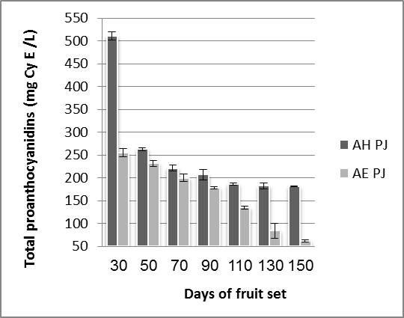
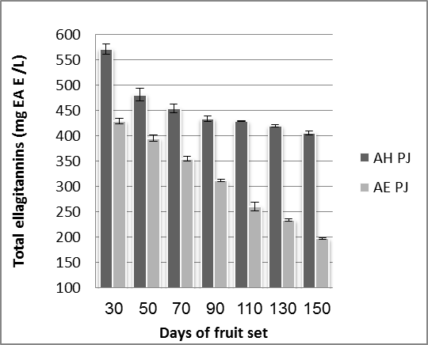

Fig.5.: Total Proanthocyanidins content represented as mg cyanidin equivalents (cy E) ,and Total Ellagitannins content represented as mg Ellagic acid equivalents (EA E) per Liter of pomegranate arils juice, during fruit development and maturation in two accession (AH, AE). Data shown are the means of three replicates vertical bar represents ± standard error

3.1.4.Punicalagin and ellagic acid content
The concentration of punicalagin and ellagic acid was studied in the aril juice of AH and AE pomegranate accessions during maturation. Punicalagin concentration showed Progressive decreasing from 30 to 150 day-old fruit in both accession. In general punicalagin concentration was higher in AH accession in all maturation levels, the highest concentration ( 319mg/L) were recorded in 30 day-old fruit in AH accession which have an astringe taste. (Fig. 6) that agree with ²⁹which reported that Punicalagin ranged from 4-565mg/L in selected pomegranate aril juices.

Rahaf Al-Halabi et al /Int.J.ChemTech Res.2013,5(6) 2676

Free ellagic acid present in low concentration compared to ellagitannins in pomegranate juice in both accessions.The highest concentration(55mg/L) was recorded in 130 day-old fruit in AH accession and in 70 day-old fruit in AE accession (47mg/L). (Fig. 6)
There is no progressive decreasing or increasing in free ellagic acid concentration during maturation. This may be due the degree of undergoing in ellagitannins composition reactions which consume ellagicacide and decrease free ellagic acid concentration. Ellagitannins are hydrolyzed to ellagic acid under physiological conditions ³⁰. Hydrolysis of ellagitannins could cause an increasing of free ellagic acid concentration. Free ellagic acid concentration was very low and out of detection limit insix maturation stages in AE accessions.
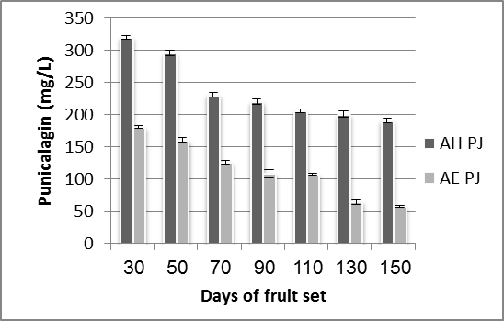
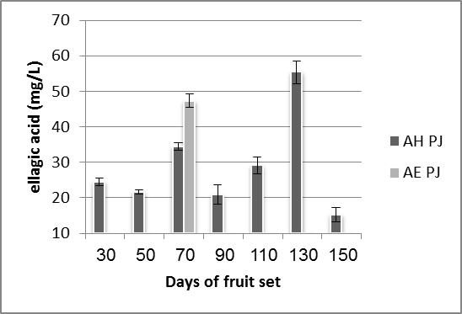

Fig. 6.: Punicalagin, and ellagic acid concentration of pomegranate arils juice represented as mg per Liter, during fruit development and maturation in two accession (AH, AE). Data shown are the means of three replicates vertical bar represents ± standard error.

3.2. Antioxidant activity
The DPPH and FRAP methods were used for determination of antioxidant activity,the values calculated as equivalent to ascorbic acid for FRAP assay. FRAP Assay showed that the level of antioxidant activity was signiﬁcantly reduced during the maturation in AE accession from (17.19_{(30 day-old fruit)} to 9.27_{(150 day-old fruit)} mM AE/L). However, a slight reduction from (22.45_{(30 day-old fruit)} to 17.45_{(150 day-old fruit)} mM AE/L ) (Fig. 7)was observed in AH accessions which has a high phenolics level, this results agree with DPPH assay results which showed that antioxidant activity was signiﬁcantly reduced during the maturation in AE accession from (87.15%_{(30 day-old fruit)} to 74.12%_{(150 day-old fruit)}) and slightly (from 92.41%_{(30 day-old fruit)} to 89.10%_{(150 day-old fruit)}) in AH accession(Fig. 7).

Rahaf Al-Halabi et al /Int.J.ChemTech Res.2013,5(6) 2677

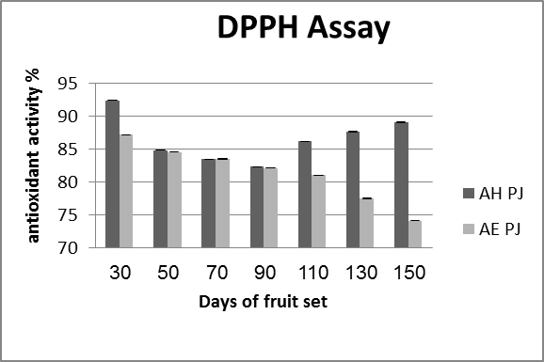
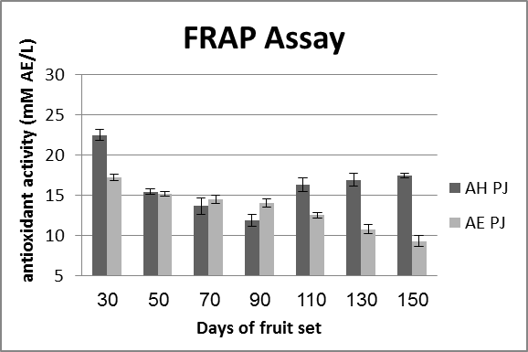

Fig. 7: Antioxidant activity of pomegranate arils juice by FRAP assay represented as mmol of ascorbic acid equivalents(AE) per L juice ,and DPPH assay represented as percentage, during fruit development and maturation in two accession (AH, AE). Data shown are the means of three replicates vertical bar represents ± standard error.

The highest antioxidant activity was recorded in 30 day-old fruit in both accessions the result also showed that AH accession which relatively had a high concentration of Phenolic had stronger antioxidant activities than AE accession
AH accession showed a rapid decrease in antioxidant activity from 30 to 50 days of fruit development in both assays, followed by slightly decrease to 90 day-old fruit, this is correlated with total phenolic level which decreased in the same way, correlation coefficient between total phenolic concentration and antioxidant activity% ,by DPPH, from 30 to 90 day -old fruit of AH accession was (r² = 0.975).while High correlation between total phenolic concentration and antioxidant activity% ,by DPPH, from 30 to 150 day -old fruit noticed in AE accession (r² =0.982) (Fig. 8). A surge in antioxidant activity from the 90 day-old fruit onwards noticed only in AH accession.Such surge noticed in ‘Ganesh’ accession was attributed to an increased concentration of anthocyanin pigments. ²The surge in AH accession might be attributed to many other non-phenolic antioxidant activities maybe such as ascorbic acid concentration that may increase⁴ or decrease ² during ripening depending on pomegranate accession, or composition of Millared reaction products ,this reaction may occur in flesh of fruit during repining in suitable conditions such as pH and temperature..³¹

Rahaf Al-Halabi et al /Int.J.ChemTech Res.2013,5(6) 2678

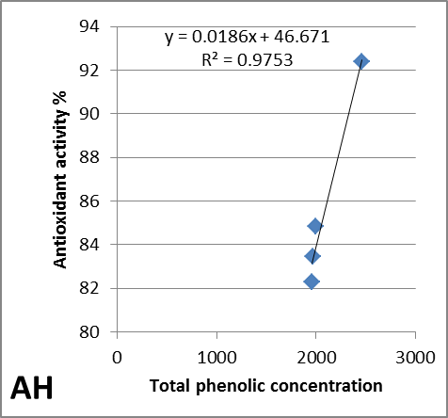
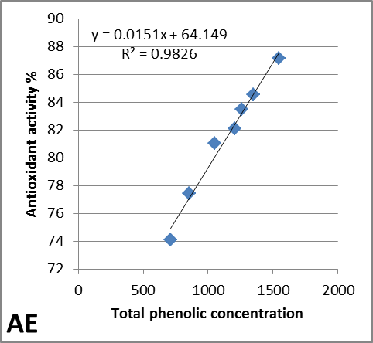

Fig.8: antioxidant activity (by DPPH) of pomegranate arils juice obtained from different ages of fruit of AE and AH vs total phenolic content as gallic acid equivalents.

3.3. Inhibition of low density lipoprotein (LDL) oxidation
In the current study, we examined the inhibitive action of pomegranate arils juice (from the different ages of fruits of the two accessions)against CuSO4-induced LDL oxidation, as evidenced by decreased conjugated dienes (measured at 234 nm) production.
The results showed that pomegranate arils juice of AH accession (in all studied maturation stages) were more effective in reducing LDL oxidation. Thehighest inhibition of LDL oxidation was observed using juice of the 30 day-old fruit of AH accession, the juice of (90,110,130,150) day-old fruit of AH accession had very similar inhibitive action (Fig. 9).
We investigate the relation between the percent inhibition of LDL oxidation (at the 60 minute of reaction) calculated as [(A _{of control} – A _{of sample})/A _{of control}] × 100 of pomegranate arils juice (from the different ages of fruits of the two accessions) and the corresponding concentration of total phenolic, a high correlation were found in both accession (Fig. 10 ).
Our results agree with^{16,32} reported that pomegranate juice could effectively protect LDL against oxidation in vitro, which was attributed to the polyphenols contained in the juice.
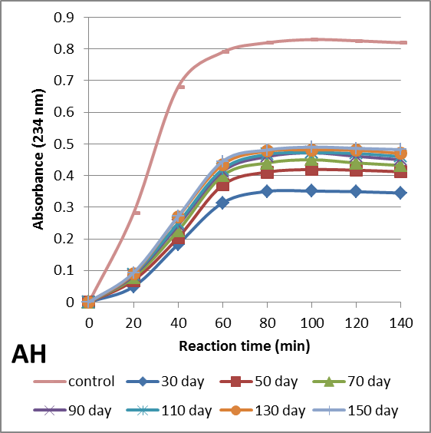
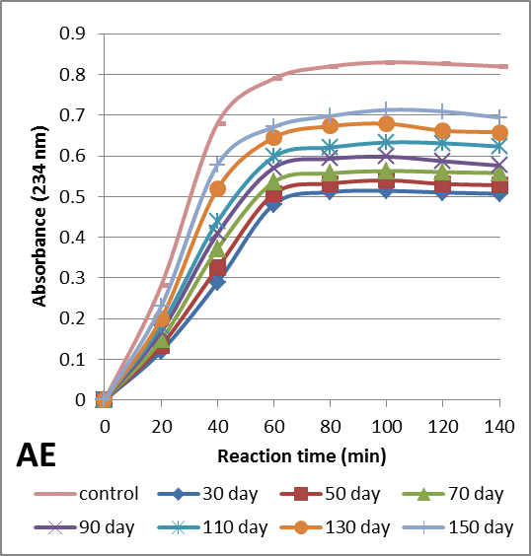

Fig. 9: The inhibitory effect of pomegranate arils juice obtained from different ages of fruit of AE and AH accessions on Cu2+induced-LDL oxidation. Oxidation was determined by monitoring the change at 234 nm due to increase in conjugated dienes formation for 120 min. All results are the averages of triplicate measurements.

Rahaf Al-Halabi et al /Int.J.ChemTech Res.2013,5(6) 2679

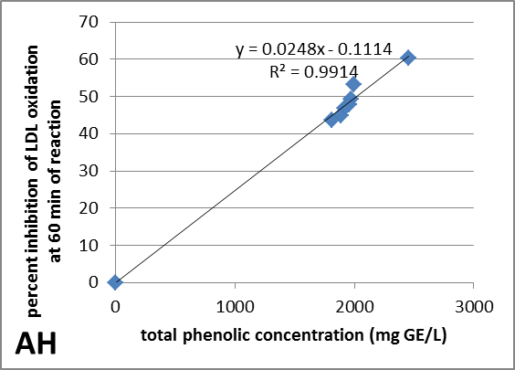
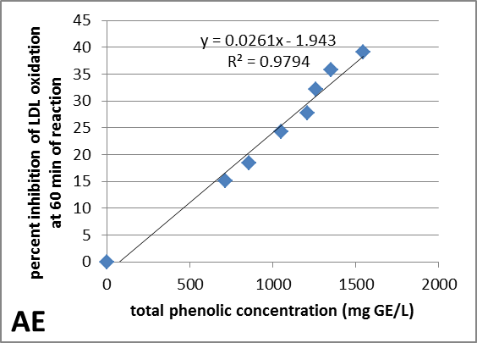

Fig. 10: percent inhibition of LDL oxidation (at the 60 minute of reaction) by pomegranate arils juice obtained from different ages of fruit of AE and AH vs total phenolic content as gallic acid equivalents.

4.Conclusion
During fruit development and maturation, signiﬁcant changes were found in the chemical proﬁle of pomegranate arils .Basically, the two accessions that were tested showed a similar trend in most of the aril parameters examined. For example, the levels of antioxidant activity, total phenolics compounds,flavonoids, ellagitannins, proanthocyanidines were reduced during maturation in the aril juice, while the levels of anthocyanins, increased. Some trends can be found in one accession but not in the other. For example, a surge in antioxidant activity in the last maturation stages in AH accession. The levels of major polyphenolics such as flavonoids, Proanthocayanidins, and ellagitannins were higher in AH(the astringe accession).While the level of anthocyanins was higher in AE (the sweet accession).
Punicalagin (the most important bioactive compound in pomegranate) present in considerable concentration in two accession especially AH accession. Isolation this bioactive compound for further studies is advisable to be in the first steps of maturation since concentration of punicalagin is the highest in 30 day-old fruit.
This data are very useful for determination of the fruit quality, as well as determine the optimum time for extract individual health-promoting compounds that varied signiﬁcantly according to the developmental stage and cultivar.

References

1. Özgen, M., Durgac, C., Serce, S., Kaya, C., Chemical and antioxidant properties of pomegranate cultivars grown in the Mediterranean region of Turkey, Food Chemistry, 2008, 111, 703–706.
2. Kulkarni, A.P., Aradhya, S.M. , Chemical changes and antioxidant activity in pomegranate arilsduring fruit development, Food Chemistry, 2005, 93, 319–324.
3. Ricci, D., Giamperi, L., Bucchini, A., Fratemale, D. Antioxidant activity of Punicagranatum fruits, Fitoterapia, 2006 ,77, 310–312.
4. Shwartz , E. Glazer, I. Bar-Ya’akov, I. Matityahu, I. Bar-Ilan, D. Amir,R., Changes in chemical constituents during the maturation and ripening of two commercially important pomegranate accessions, Food Chemistry , 2009, 115, 965–973.
5. Aviram, M., Volkova, N., Coleman, R., Dreher, M., Reddy, M. K., Ferreira, D., Pomegranate phenolics from the peels, arils, and ﬂowers are antiatherogenic: Studies in vivo in atherosclerotic apolipoprotein e-deﬁcient (E 0) mice and in vitro in cultured macrophages and lipoproteins. Journal Agriculture Food Chemistry, 2009, 56, 1148–1157.

Rahaf Al-Halabi et al /Int.J.ChemTech Res.2013,5(6) 2680

6. Gil, M. I., Tomas-Barberan, F. A., Hess-Pierce, B., Holcroft, D. M., & Kader, A. A. Antioxidant activity of pomegranate juice and its relationship with phenolic composition and processing. Journal of Agriculture and Food Chemistry,2000, 48, 4581–4589.
7. Basu, A., Penugonda, K., Pomegranate juice: a heart-healthy fruit juice. Nutr.Rev, 2009, 67,49–56.
8. El Kar, C. Ferchichi, A.Attia, F. Bouajila, J., Pomegranate (Punicagranatum) juices: chemical composition, micronutrient cations, and antioxidant capacity. Food Scince, 2011, 76(6), 795-800.
9. Çama,M.Hisli,Y. Durmaz,G., Classiﬁcation of eight pomegranate juices based on antioxidant capacity measured by four methods. Food Chemistry, 2009, 112, 721–726.
10. Seeram, N. P., Lee, R., & Heber, D. , Bioavailability of ellagic acid in human plasma after consumption of ellagitannins from pomegranate (Punicagranatum L.) juice. ClinicaChimicaActa, 2004, 348, 63–68.
11. Seeram, N. P., Zhang, Y., Reed, J. D., Krueger, C. G., &Vaya, J., Pomegranate phytochemicals. Pomegranates: Ancient Roots to Modern Medicine. Taylor and Francis GROUP,New York, 2006,3–29
12. Tyagi, S., Singh, A., Bhardwaj, P., Sahu, S., Yadav, AP., Kori, ML., Punicalagins-A Large Polyphenol Compounds Found in Pomegranates: A Therapeutic Review. Academic Journal of Plant Science,2012, 5 (2), 45-49.
13. Viuda-Martos, M., et al., Antioxidant properties of pomegranate (Punicagranatum L.) bagasses obtained as co-product in the juice extraction, Food Research International,2010 doi:10.1016/j.foodres. 2010.10.057.
14. Vermerris, W. Nicholson, R. , Phenolic Compound Biochemistry: Phenolic Compounds and their Effects on Human Health, 2006, Springer, Netherlands.
15. Tezcan, F., Gultekin-Ozguven, M., Diken, T., Ozcelik, B., &Erim, F.B., Antioxidant activity and total phenolics, organic acid and sugar content in commercial pomegranate juices. FoodChemistry, 2009, 115, 873–877.
16. Yunfeng, L., G. Changjiang, Y. Jijun, W. Jingyu, X. Jing, & C. Shuang, Evaluation of antioxidant properties of pomegranate peel extract in comparison with pomegranate pulp extract, Food Chemistry, 2006, 96, 254-260.
17. Zhang, Y., Wang, D., Lee, R. P., Henning, S. M., Heber, D., "Absence of Pomegranate Ellagitannins in the Majority of Commercial Pomegranate Extracts: Implications for Standardization and Quality Control". Journal of Agricultural and Food Chemistry, 2009, 57 (16), 7395–7400.
18. Saraçoğlu,O., Özgen,M. , Total phenolic distribution of juice, peel, and seed extracts of four pomegranate cultivars. Pharmacogn Mag, 2011, 26, 161–164.
19. Goldstein, J., Swain, T. , Changes in tannins in ripening fruits. Phytochemistry, 1963, 2(4), 371–383.
20. Amiot, J. M., Tacchini, M., Aubert, S. Y., &Oleszek, W. , Inﬂuence of cultivar, maturity stage and storage conditions on phenolic composition and enzymatic browning of pear fruit. Journal of Agriculture Food Chemistry,1995, 43, 1132–1137.
21. Gull, J., Sultana, B., Anwar, F., Naseer, R., Ashraf, M. Ashrafuzzaman, M. , Variation in Antioxidant Attributes at Three Ripening Stages of Guava (Psidiumguajava L.) Fruit from Different Geographical Regions of Pakistan.Molecules, 2012, 17, 3165-3180.
22. Mirdehghan,s. Rahemi,M., Seasonal changes of mineral nutrients and phenolics in pomegranate (Punicagranatum L.) fruit. ScientiaHorticulturae , 2007, 111, 120–127.
23. Zarei,M., Aziz,M., Bashir-Sadr,Z., Evaluation of physicochemical characteristics of pomegranate (Punicagranatum L.) fruit during ripening. Fruits, 2011, 66, 121–129.
24. Wang, S,. Chen b, C., The inﬂuence of light and maturity on fruit quality and ﬂavonoid content of red raspberries. Food Chemistry ,2009, 112, 676–684.
25. Petit, P .,Granier, T. ,Estaintot, B., Manigand,C .,Bathany,K. ,chmitter,J. ,Lauvergeat, V. ,Hamdi, S. ,Gallois, B., Crystal Structure of Grape Dihydroflavonol 4-Reductase, a Key Enzyme in Flavonoid Biosynthesis. Molecular Biology, 2007, 368 (5), 1345–1357.
26. Jaakola, L., Määttä, K., Pirttilä, AM., Törrönen, R., Kärenlampi, S., Hohtola, A., Expression of genes involved in anthocyanin biosynthesis in relation to anthocyanin, proanthocyanidin, and flavonol levels during bilberry fruit development. Plant Physiol, 2002, 130(2), 729-39.

Rahaf Al-Halabi et al /Int.J.ChemTech Res.2013,5(6) 2681

27. Fakin, A.G. , Medicinal plants: Traditions of yesterday and drugs of tomorrow. Molecular Aspects of Medicine,2006, 27, 24-25.
28. Reddy, N.R., Pierson, M. D., Sathe, S.K., Salunkhe, D.K., Dry bean tannins: A review of nutritional implications. Journal of the American Oil Chemists Society, 1985, 62(3), 541-549.
29. Fischer, U.A., Carle, R., Kammerer, D.R., Identification and quantification of phenolic compounds from pomegranate (Punicagranatum L.) peel, mesocarp, aril and differently produced juices by HPLC-DAD-ESI/MS(n). Food Chemistry, 2011, 127(2),807-821.
30. Landete, J.M., Ellagitannins, ellagic acid and their derived metabolites: A review about source, metabolism, functions and health. Food Research International, 2011, 44, 1150–1160.
31. Rinderknecht, H. , The free amino acid pattern of dates in relation to their darkning during maturation and storage. Journal of Food Science, 1959, 24: 298–304. doi: 10.1111/j.1365-2621.1959.tb17275.x.
32. Aviram, M., Dornfeld, L., Rosenblat, M., Volkova, N., Kaplan, M., Coleman, R., et al. , Pomegranate juice consumption reduces oxidative stress, atherogenic modiﬁcations to LDL, and platelet aggregation: studies in humans and in atherosclerotic apolipoprotein E-deﬁcient mice. American Journal of Clinical Nutrition, 2000, 71, 1062–1076.

*****

